ENG10-3.1.28.1

IALA S-245
Product Specification

Draft 0.0.1 – September 2019

IALA S-245 Product Specification

Document Revisions
Revisions to the IALA Document are to be noted in the table prior to the issue of a revised document.
Date | Page / Section Revised | Requirement for Revision

Table of Contents
Contents
1 Overview 5
1.1 Introduction 5
1.2 References 5
1.2.1 Normative References 5
1.2.2 Informative References 5
1.3 Terms, Definitions and abbreviations 6
1.3.1 Terms and definitions 6
1.3.2 Acronyms 8
1.4 Product Specification metadata 9
1.4.1 IALA Product Specification Maintenance 9
2 Specification Scope 10
3 Data Product Identification 11
4 Data Content and structure 11
4.1 Introduction 11
4.2 Application Schema 12
4.3 Feature Catalogue 13
4.4 Data Product Types 14
4.5 Data Product Loading and Unloading 14
4.6 Geometry 14
4.6.1 Regular grids 14
4.6.2 Points 16
5 Co-ordinate reference systems (CRS) 17
5.1 Introduction 17
5.2 Horizontal reference system 17
5.3 Vertical reference system 17
5.4 Temporal reference system 17
6 Data Quality 18
6.1 Assessment of data 18
6.2 Additional components of data quality 18
7 Data Capture and classification 18
8 Data Maintenance 18
8.1 Maintenance and update frequency 18
8.2 Data source 18
8.3 Production process 18
9 Portrayal 19
10 Data Product format (Encoding) 19
10.1 Introduction 19
10.2 Product structure 19
11 Data Product delivery 20
11.1 Introduction 20
11.2 Exchange datasets 21
11.3 Exchange catalogue 21
11.4 Data product file naming conventions 22
11.5 Support files 22
12 Metadata 22
12.1 Introduction 22
12.2 Discovery metadata 22

Overview

Introduction

This document has been produced by the ENG Committee of IALA in response to a requirement to produce an eLoran ASF data product that can be used within an eLoran receiver. It is based on the IHO S-100 framework specification and the ISO 19100 series of standards. It is a grid product specification that is primarily intended for encoding eLoran ASF data.

References

Normative References

The following normative documents contain provisions that, through reference in this text, constitute provisions of this document.

IHO S-100 IHO Universal Hydrographic Data Model Edition 4.0.0 (December 2018).
ISO 8601:2004. Data elements and interchange formats - Information interchange - Representation of dates and times. 2004.
ISO 3166-1. 1997. Country Codes. 1997.
ISO 19101-2:2008 Geographic Information - Rules for Application Schema
ISO/TS 19103:2005 Geographic Information - Conceptual schema language
ISO 19106:2004 Geographic Information – Profiles
ISO 19107:2003 Geographic Information – Spatial schema
ISO 19109:2005 Geographic Information - Rules for Application Schema
ISO 19111:2003 Geographic Information - Spatial referencing by coordinates
ISO 19115:2003+Corr1 (2006) Geographic Information - Metadata
ISO 19115-2:2009 Geographic Information - Metadata: Extensions for imagery and gridded data
ISO 19123:2005 Geographic Information - Schema for coverage geometry and functions
ISO 19129:2009 Geographic Information - Imagery gridded and coverage data framework
ISO 19131:2007 Geographic Information - Data product specifications
ISO 19136:2007 Geographic Information – Geography Markup Language
ISO 19136-2:2015, Geographic Information – Geography Markup Language.
ISO/TS 19139, Geographic Information – Metadata – XML schema implementation.

Informative References

The following informative documents provide additional information, including background information, but are not required to develop applications for data conforming to this specification.

ISO/IEC 19757-3, Information technology – Document Schema Definition Languages (DSDL) – Part 3: Rule-based validation – Schematron.
ISO/TS 19130:2010 Geographic information - Imagery sensor models for geopositioning. 2010
ISO/TS 19130-2:2010 Geographic information - Imagery sensor models for geopositioning - Part 2. 2010
ISO 19132:2007 Geographic information - Location-based services – Reference model. 2007
ISO 19133:2005 Geographic Information - Location-based services - Tracking and navigation. 2005
ISO 19144-1:2009 Geographic information - Classification systems – Part 1: Classification system structure. 2009
ISO 19145:2010 Geographic information - Registry of representations of geographic point location. 2010
ISO 19153:2010 Geographic information - Geospatial Digital Rights Management Reference Model (GeoDRM RM) 1). 2010
ISO 19156:2010 Geographic information - Observations and measurements. 2010
ISO 19157:2010 Geographic information - Data quality. 2010
ISO 19158:2010 Geographic Information - Quality assurance of data supply. 2010

Terms, Definitions and abbreviations

Terms and definitions

The S-100 framework is based on the ISO 19100 series of geographic standards. The terms and definitions provided here are used to standardize the nomenclature found within that framework, whenever possible.

application
manipulation and processing of data in support of user requirements (ISO 19101)

application schema
conceptual schema for data required by one or more applications (ISO 19101)

conceptual model
model that defines concepts of a universe of discourse (ISO 19101)

conceptual schema
formal description of a conceptual model (ISO 19101)

coverage
feature that acts as a function to return values from its range for any direct position within its spatial, temporal or spatiotemporal domain (ISO 19123)
EXAMPLE Raster image, polygon overlay, digital elevation matrix.

data product
dataset or dataset series that conforms to a data product specification

data product specification
detailed description of a dataset or dataset series together with additional information that will enable it to be created, supplied to and used by another party
NOTE: A data product specification provides a description of the universe of discourse and a specification for mapping the universe of discourse to a dataset. It may be used for production, sales, end-use or other purpose.

dataset
identifiable collection of data (ISO 19115)
NOTE: A dataset may be a smaller grouping of data which, though limited by some constraint such as spatial extent or feature type, is located physically within a larger dataset. Theoretically, a dataset may be as small as a single feature or feature attribute contained within a larger dataset. A hardcopy map or chart may be considered a dataset.

dataset series
collection of datasets sharing the same product specification (ISO 19115)

domain
well-defined set (ISO/TS 19103)
NOTE: Well-defined means that the definition is both necessary and sufficient, as everything that satisfies the definition is in the set and everything that does not satisfy the definition is necessarily outside the set.

feature
abstraction of real world phenomena (ISO 19101)
NOTE: A feature may occur as a type or an instance. Feature type or feature instance shall be used when only one is meant.

feature association
relationship that links instances of one feature type with instances of the same or a different feature type (ISO19110)
NOTE 1; A feature association may occur as a type or an instance. Feature association type or feature association instance is used when only one is meant.
NOTE 2: Feature associations include aggregation of features.

feature attribute
characteristic of a feature (ISO 19101)
NOTE 1: A feature attribute may occur as a type or an instance. Feature attribute type or feature attribute instance is used when only one is meant.
NOTE 2: A feature attribute type has a name, a data type and a domain associated to it. A feature attribute for a feature instance has an attribute value taken from the domain.

geographic data
data with implicit or explicit reference to a location relative to the Earth (ISO 19109)
NOTE: Geographic information is also used as a term for information concerning phenomena implicitly or explicitly associated with a location relative to the Earth.

metadata
data about data (ISO 19115)

model
abstraction of some aspects of reality (ISO 19109)

portrayal
presentation of information to humans (ISO 19117)

quality
totality of characteristics of a product that bear on its ability to satisfy stated and implied needs (ISO 19101)

universe of discourse
view of the real or hypothetical world that includes everything of interest (ISO 19101)

Acronyms

This product specification adopts the following convention for symbols and abbreviated terms:
ASCII American Standard Code for Information Interchange
ECDIS Electronic Chart Display and Information Systems
ENC Electronic Navigational Chart
GML Geography Markup Language
IHO International Hydrographic Organization
IOC International Oceanographic Commission
ISO International Organization for Standardization
NIPWG Nautical Information Provision Working Group
NPIO Nautical Publication Information Overlay
UML Unified Modelling Language
URI Uniformed Resource Identifier
URL Uniform Resource Locator
WGS World Geodetic System
XML Extensible Markup Language
XSLT eXtensible Stylesheet Language Transformations

Product Specification metadata

Title | eLoran ASF data Product Specification
Identifier | 0.0.1
S-100 version | 4.0.0
Date | 1 September 2019
Language | English
Classification: | 001 - unclassified
Contact: | IALA-AISM  10, rue des Gaudines  78100 Saint Germain en Laye, France  Telephone: +33 1 34 51 70 01 Fax: +33 1 34 51 82 05
URL: | iala-aism.org
Maintenance: | The product specification is maintained by IALA-AISM and amendments are performed on a needs base, up to maximum one new release per calendar year.

IALA Product Specification Maintenance
This chapter is for clarification only on PS Maintenance.

Introduction
Changes to a product specification will be released by IALA-AISM as a new edition, revision, or clarification.

New Edition
New editions of a product specification introduce significant changes. New editions enable new concepts, such as the ability to support new functions or applications, or the introduction of new constructs or data types.

Revisions
Revisions are defined as substantive semantic changes to a product specification. Typically, revisions will change a product specification to correct factual errors; introduce necessary changes that have become evident as a result of practical experience or changing circumstances. A revision must not be classified as a clarification. Revisions could have an impact on either existing users or future users of a product specification. All cumulative clarifications must be included with the release of approved corrections.
Changes in a revision are minor and ensure backward compatibility with the previous versions within the same edition. Newer revisions, for example, introduce new features and attributes. Within the same edition, a data product of one version could always be processed with a later version of the feature and portrayal catalogues.

Clarification
Clarifications are non-substantive changes to a product specification. Typically, clarifications: remove ambiguity; correct grammatical and spelling errors; amend or update cross references; insert improved graphics, spelling, punctuation and grammar. A clarification must not cause any substantive semantic change to a product specification.
Changes in a clarification are minor and ensure backward compatibility with the previous versions within the same edition. Within the same edition, a data product of one clarification version could always be processed with a later version of the feature and portrayal catalogues, and a portrayal catalogue can always rely on earlier versions of the feature catalogues.

Version Numbers
The associated version control numbering to identify changes (n) to a product specification must be as follows:
New editions denoted as n.0.0
Revisions denoted as n.n.0
Clarifications denoted as n.n.n

Specification Scope
This product specification describes one data product and therefore requires only one scope which is described below:

Scope ID: eLoran ASF data

Hierarchical level: MD_ScopeCode - 005

Hierarchical level name: dataset.

Level description: information applies to the dataset

Extent: EX_Extent.description: Global coverage of maritime areas

Data Product Identification
This clause describes how to identify data sets that conform to the specification. A dataset that conforms to this Product Specification may be identified by its discovery metadata as defined in clause 13 of this specification. The information identifying the data product may include the following items from S-100 4.0.0 clause 11-6 (adapted from ISO 19115-1).

Title | eLoran ASF data
Alternate Title
Abstract | eLoran ASF data 설명 자료
Topic Category
Geographic Description | EX_GeographicDescription: E.g., official name of region
Spatial Extent | MD_Resolution>equivalentScale.denominator (integer) or MD_Resolution>levelOfDetail (CharacterString). E.g.: “All scales”
Description | eLoran ASF data 설명 자료
Spatial Resolution | MD_Resolution>equivalentScale.denominator (integer) or MD_Resolution>levelOfDetail (CharacterString). E.g.: “All scales”
Purpose | eLoran ASF data 목적
Language | EN
Spatial Representation Type
Point of Contact | IALA-AISM  10, rue des Gaudines  78100 Saint Germain en Laye, France  Telephone: +33 1 34 51 70 01 Fax: +33 1 34 51 82 05
Use Limitation

Data Content and structure

Introduction

This Section discusses the Application Schema, which is described in UML; the Feature Catalogue; dataset types.

The eLoran ASF data product is based on the S-100 General Feature Model (GFM), and is a raster-based grid product.

Application Schema
This Application Schema shall be expressed in UML.

The UML models shown below are segments of the overall S-245 application schema, and include overviews of the feature classes, information classes, meta features, spatial types, and the relationships between them.

This section contains a general overview of the classes and relationships in the S-245 application schema. Detailed information about how to use the feature types and information types to encode Marine Traffic Management information is provided in the S-245 Data Classification and Encoding Guide (DCEG).

The following conventions are used in the UML diagrams depicting the application schema:

- Standard UML conventions for classes, associations, inheritance, roles, and multiplicities apply. These conventions are described in Part 1 of S-100.
- Italic font for a class name indicates an abstract class.
- Feature classes are depicted with green background; the dark shade for abstract feature classes and the light shade for ordinary (non-abstract) feature classes.
- Information type classes are depicted with blue background; the dark shade for abstract information type classes and the light shade for ordinary information types.
- Association classes are depicted with a white background.
- Complex attributes are depicted with a pink background.
- Enumeration lists and codelists are depicted with a tan background. The numeric code corresponding to each listed value is shown to its right following an ‘=’ sign.
- No significance attaches to the color of associations. (Complex diagrams may use different colors to distinguish associations that cross one another.)
- Where the association role or name is not explicitly shown, the default rules for roles and names apply:
  - The role name is ‘the<CLASSNAME>’ where <CLASSNAME> is the name of the class to which that association end is linked.
  - The association name is ‘<CLASSNAME1>_<CLASSNAME2>’ where <CLASSNAME1> is the source and <CLASSNAME2> the target. In case of a feature/information association the feature is the source. For feature/feature or information/information associations without explicit names the source/target are indicated by an arrowhead.
- Subclasses inherit the attributes and associations of their super classes at all levels, unless such inheritance is explicitly overridden in the subclass.

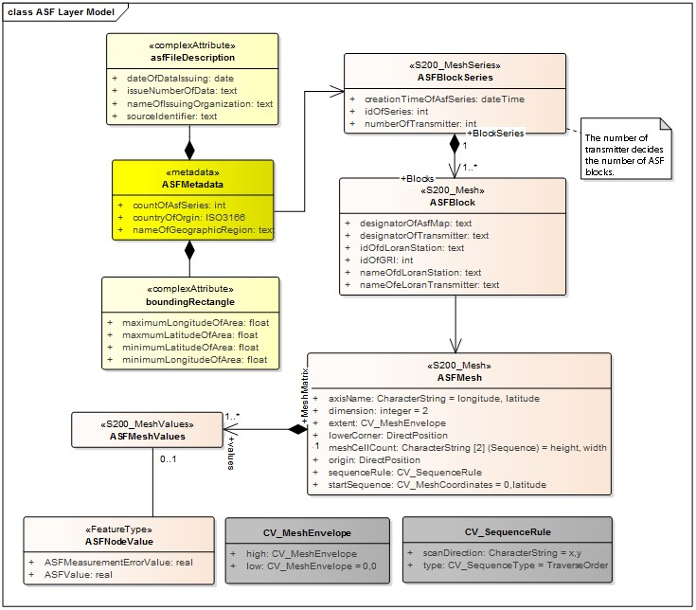

Feature Catalogue

The Feature Catalogue describes the feature types, information types, attributes, attribute values, associations and roles which may be used in the product. The S-245 Feature Catalogue is available in an XML document which conforms to the S-100 XML Feature Catalogue Schema and can be downloaded from the IALA website (http://www.iala-aism.org).
Name: eLoran ASF data Feature Catalogue
Scope: Ocean, Coastal, Ports, Harbors and Inland waters
Version Number: 0.0.1
Version Date: 2019-09-01
Producer: IALA-AISM
10, rue des Gaudines
78100 Saint Germain en Laye, France
Telephone: +33 1 34 51 70 01 Fax: +33 1 34 51 82 05
Language: English

Data Product Types

Optional

Data Product Loading and Unloading

Optional

Geometry

eLoran ASF data are represented in two ways: arrays of points contained in a regular grid, and sets of points not described by a regular grid. Further details on the data product are given in Clause 10 – Data Product Format.
The eLoran ASF data have structures that can be described by two S-100 coverages: S100_PointCoverage and S100_GridCoverage (S-100 v 4.0.0, Clause 8-7).
Grid Coverage The class S100_GridCoverage represents a set of values assigned to the points in a two-dimensional grid. Attributes include interpolationType, dimension, axisNames, origin, coordinateReferenceSystem, offsetVectors, extent, sequencingRule, startSequence, and rangeType.
Point Coverage The class S100_PointCoverage represents a set of values, such as speed and direction values, assigned to a set of arbitrary X,Y points. Each point is identified by a horizontal coordinate geometry pair (X,Y) and assigned one or more values as attribute values. These values are organized in a record for each point. Attributes include domainExtent, rangeType, metadata, commonPointRule, geometry, and value.

Regular grids

S-245 regular grid geometry is an implementation of S100_GridCoverage (Part 8 – Imagery and Gridded Data). The spatial grids for the regular grid type are two dimensional, orthogonal, and georeferenced (with the X axis directed toward the east), and are defined by several attributes, including grid origin, spacing, and grid indexing. Current speed and direction values apply at the vertices of the grid, i.e., the intersections of the row and column lines. These parameters are explained in more detail below. A typical regular grid and some of its parameters are shown in Figure 4.2.

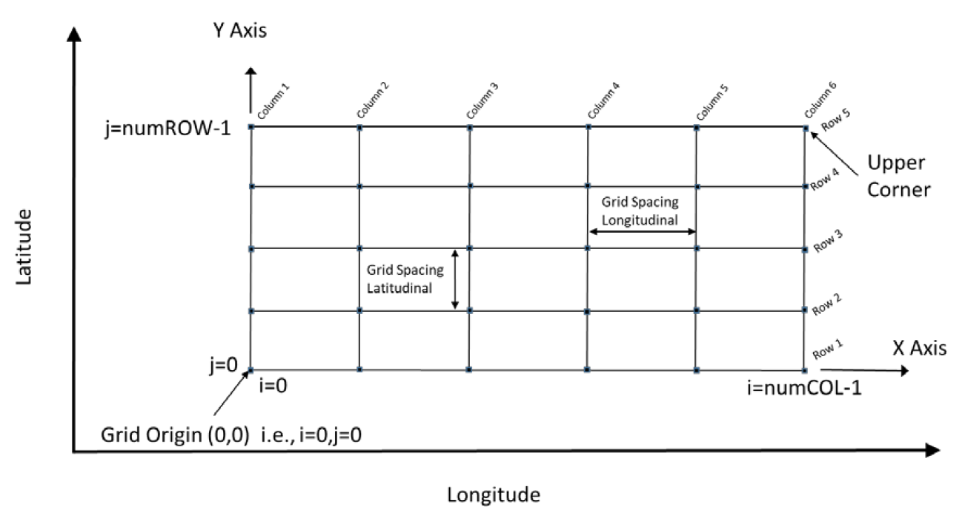
Figure 4.2 – Schematic of the regular grid and some of its attributes

Vertices are shown as the filled squares at the intersections of the rows and columns. The offsetVectors are shown as the Latitudinal Spacing and Longitudinal Spacing. The origin is shown at the lower left corner of the grid.
The grid is oriented to the Earth by the Coordinate Reference System (CRS), with the variable coordinateReferenceSystem. The origin contains the latitude and longitude as a DirectPosition and is located at the point at the lower left (southwest) extent of the grid. The upper corner is the northwesternmost point in the grid. The attribute dimension is 2, and the variable interpolationType has the value of ‘discrete’, since there is no spatial interpolation used for eLoran ASF data.
S-245 grids allow for different spacing of points along the X (longitudinal) axis and the Y (latitudinal) axis. For rectangular grids the offset vector establishes the cell size. The attribute offsetVectors carries the two vectors for grid spacing (Latitudinal Spacing and Longitudinal Spacing). The first vector is 90 degrees clockwise from CRS north, and represents the distance between grid values on the X axis. The second vector is 0 degrees clockwise from CRS north, and represents the distance between the values on the Y axis. The distances are given in degrees.
The attribute extent effectively defines a bounding rectangle describing where data is provided. The attribute extent carries two sub attributes; low and high. The sub attribute low carries the value “0, 0” to indicate the index values at the start of the extent is the southwest (lower left) corner of the grid. The sub attribute high, carries the value of the highest position along the X axis and the highest position along the Y axis. For example, if the number of rows is numROW and the number of columns is numCOL, then the index values for high would be ‘numCOL-1,numROW-1’. Together they form the grid coordinate of the upper right corner.
The sequence rule for a regular cell size grid is straightforward. When the cells all have the same dimensions, the cell index can be derived from the position of the Record within the sequence of Records. The attribute sequencingRule has two subattributes; type and scanDirection. The sub attribute type carries the value “linear”, and the subattribute scanDirection carries the value “X,Y”. Together with the value “0,0” stored in the attribute startSequence, they indicate that for S-245 the grid values along the X axis at the lowest Y axis position are stored first, starting with the left most value going right, followed by the values along the X axis at the next increment upward along the Y axis, and so on till the top of the Y axis. The last value in the value sequence of the grid will be at the top rightmost positon in the grid. In the figure, first all columns in row 1 are selected, then all columns in row 2, and so on.

Points

The S-245 PointCoverage is quite flexible and is used herein to describe three broad categories of spatial data: one or more current stations at fixed locations, ungeorectified gridded data, and drifting platform data.
For this type of data (Figure 4.3), the axisNames are the same as for the regular grid. However, the origin is arbitrary, and the extent (cf. the bounding rectangle) may be defined by the minimum and maximum of the geographic positions of the stations. The total number of locations (tidal current stations, ungeorectified grid points, or drifter locations) must be specified. Also, attributes like gridSpacingLongitudinal and scanDirection have no meaning. The position of the locations is carried in the one-dimensional arrays X and Y.

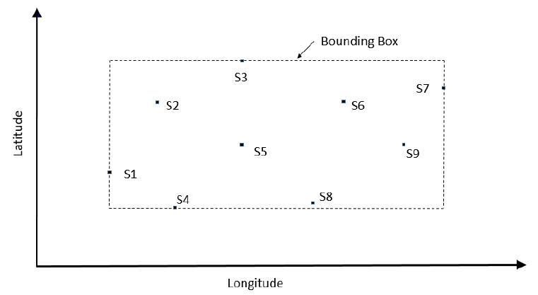
Figure 4.3 – Schematic of the point coverage and some of its attributes

The points, which may represent fixed stations or nodes in an ungeorectified grid, appear as filled-in rectangles, are labeled and have a format such as ‘S1’.

Co-ordinate reference systems (CRS)

Introduction
The location of a feature in the S-100 standard is defined by means of coordinates, which relate a feature to a position. The S-245 CRS is a compound system, with a two-dimensional ellipsoidal horizontal component and a one-dimensional datum-related vertical component (cf. S-100, Part 6 – Coordinate Reference Systems).

Horizontal reference system
For an ENC the horizontal CRS must be the ellipsoidal (geodetic) system EPSG: 4326 (WGS84). The full reference to EPSG: 4326 can be found at www.epsg-registry.org.
Horizontal coordinate reference system | EPSG: 4326 (WGS84)
Projection | None
Coordinate reference system registry | EPSG Geodetic Parameter Registry
Date type (according to ISO 19115) | 002- publication
Responsible party | International Association of Oil and Gas Producers (IOGP)

Vertical reference system
The vertical coordinate is directed upward (that is, away from the Earth’s center) from its origin, the vertical datum, and has units of metres.

Temporal reference system
The temporal reference system is the Gregorian calendar for date and UTC for time. Time is measured by reference to Calendar dates and Clock time in accordance with ISO 19108:2002, Temporal Schema clause 5.4.4. A date variable will have the following 8-character format (ISO 8601): yyyymmdd. A time variable will have the following 7-character format: hhmmssZ. A date-time variable will have the following 16-character format: yyyymmddThhmmssZ.

Data Quality

Assessment of data
Data quality allows users and user systems to assess fitness for use of the provided data. Data quality measures and the associated evaluation are reported as metadata of a data product. This metadata improves interoperability with other data products and provides usage by user groups that the data product was not originally intended for. The secondary users can make assessments of the data product usefulness in their application based on the reported data quality measures.

Additional components of data quality
Additional data quality measures include Completeness, Logical Consistency, Thematic Accuracy, Aggregation, and Usability.

Data Capture and classification

S-245 products must be based on data sources released by an appropriate eLoran ASF data defining authority. Data source must be described in each data product.

The production process used to generate eLoran ASF data products may be described in the dataset metadata.

Data Maintenance

Maintenance and update frequency
eLoran ASF data has long period of change.

Data source
Data is produced by the eLoran relevant authorities by collecting observational values and running calculation models. These data are typically quality-controlled and reformatted to conform to file size limitations and the S-245 standard encoding.

Production process
S-245 data sets, including the metadata and the coverages for eLoran ASF, are updated by replacement of the entire data product. The eLoran authority routinely collect observational data and maintain an analysis and/or forecast capability. When new data become available (often several times per day), the data is reformatted and made available for dissemination.

Portrayal

TBD

Data Product format (Encoding)

Introduction
The eLoran ASF Data Product must be encoded using the Hierarchical Data Format standard, Version 5 (HDF5).
Format Name | HDF-5
Character Set | MD_CharacterSetCode (ISO 19115)
Specification | S-100 profile of HDF-5

For the use of HDF5, the following key concepts (10c-5.1) are important:
- File - a contiguous string of bytes in a computer store (memory, disk, etc.), and the bytes represent zero or more objects of the model;
- Group - a collection of objects (including groups);
- Dataset - a multidimensional array of data elements with attributes and other metadata;
- Dataspace - a description of the dimensions of a multidimensional array;
- Datatype - a description of a specific class of data element including its storage layout as a pattern of bits;
- Attribute - a named data value associated with a group, dataset, or named datatype;
- Property List - a collection of parameters (some permanent and some transient) controlling options in the library;
- Link - the way objects are connected.

In addition, a dataset may have one, two, or more dimensions, and each element in the dataset may be a compound. That is, each element may itself be an array of possibly different datatypes (float, integer, string, etc).

Product structure
The structure of the data product follows the form given in S-100 Part 10c – HDF5 Data Model and File Format. The general structure, which was designed for several S-100 products, not just eLoran ASF data, is given in Figure 10.1.
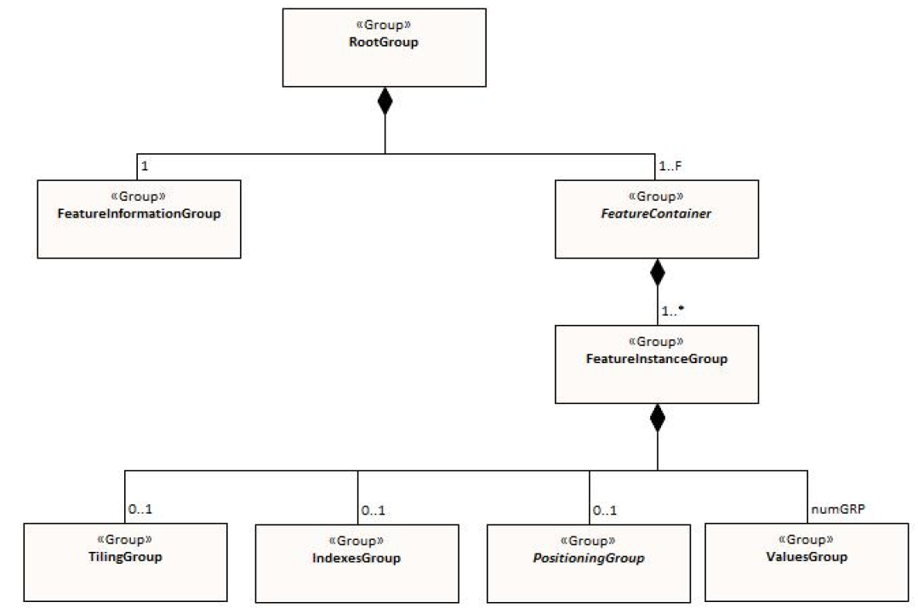
Figure 10.1 – Outline of the generic data file structure for all HDF5 formatted data files in S-100 (see Part 10c – Figure 10c-7). Note that there are four levels from top to bottom

In Figure 10.1 there are four levels:

Level 1: At the top level lies the Root Group, and it contains the Root Metadata (Table 12.1) and two subsidiary groups. The Root Metadata applies to all S-100 type products.

Level 2: The next Level contains the Feature Information Group and the Feature Container Group. The Feature Information Group contains the feature name and the feature attribute codes. The Feature Container Group contains the Feature Metadata (Table 12.2) and one or more Feature Instance Groups. The Feature Metadata is common to all eLoran ASF data products.

Level 3: This contains one or more Feature Instances. A feature instance is, for example, a time series of gridded data for a single region, or a time series of astronomical predictions for a set of stations.

Level 4: This contains the actual data for the feature. S-245 uses only the Values Group and, for only some data, the Positioning Group.

Data Product delivery

Introduction
This section describes how the eLoran ASF Data Product is to be delivered from the eLoran authority to the end user.

Method of transfer will be primarily web-based, including ftp. The data will be supplied either directly from the eLoran authority or through a third party supplier.

Due to the cost of transmitting data via Internet, it is desirable to limit file size and updating frequency whenever possible. The exchange dataset file size, as created by the eLoran authority and after compression, is recommended to be limited to 10 MB.

Another quantity to be aware of is the total MB to be transferred per year. S-100 (Sec. 15-5.2) allows one data compression scheme: Zip. In addition, the file may be encrypted.

Exchange datasets
Exchange Sets produced by the eLoran authority consist of files containing an XML Exchange Catalogue, the HDF5 Data Products, and auxiliary files (Figure 11.1). The auxiliary files include an XML Feature Catalogue, an XML Portrayal Catalogue, SVG files, and additional supporting XML files for alarms and indications, and for interoperability.

The Data Products include one or more data sets (but of the same S-100 Product Specification types), with each product covering a specific geographic region and specific period of time. The Exchange Catalogue lists the products and contains the discovery metadata.

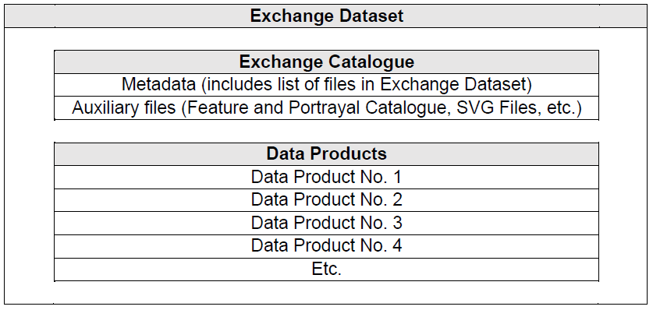
Figure 11.1 – Schematic diagram of the Exchange Dataset

Exchange catalogue
The exchange catalogue (normally in XML format) acts as the table of contents for the exchange set. The catalogue file of the exchange set must be named CATALOG.XML; no other file in the exchange set may have the same name. The contents of the exchange catalogue, which includes the metadata, are described in clause 12.

Data product file naming conventions
The dataset file contains both metadata and one or more sets of speed and direction arrays (see clause 10 – Data Product Format). The dataset name must begin with the three-character Product Specification, followed by the two-character producer code (CC).
The unrestricted characters may be used to denote geographical region, valid time, source of the data, version numbers, and/or any other relevant information. Characters may be lower or upper case.
The filename extension for HDF5 (for example .h5 or .hdf5) must be used to denote the file format.

Support files
This Data Product requires no support files.

Metadata

Introduction
For information exchange, there are several categories of metadata required:
- metadata about the overall exchange dataset and catalogue;
- discovery metadata about each of the datasets contained in the catalogue; and
- discovery metadata about the support files that make up the package.
The discovery metadata classes have numerous attributes which enable important information about the datasets and accompanying support files to be examined without the need to process the data, for example decrypt, decompress, load etc. Other catalogues can be included in the exchange set in support of the datasets such as feature, portrayal, coordinate reference systems, codelists, etc. The attribute “purpose” of the support file metadata provides a mechanism to update support files more easily.

Discovery metadata
An outline of the overall concept of an S-245 exchange set for the interchange of geospatial data and its relevant metadata is explained in the following figures. Figure 12.1 depicts the realization of the ISO 19115-1 and 19115-3 classes which form the foundation of the exchange set. The overall structure of the S-245 metadata for exchange sets is the same as S-100 metadata, with the following exceptions:
- S-245 does not use support files, and therefore does not use support file metadata;
- S-245 defines certain product-specific metadata attributes in discovery metadata, and therefore extends S-100 discovery metadata.
The structure is modelled in Figures 12.2 and 12.3. More detailed information about the various classes is shown in Figure 12.4. Whether the individual metadata parameters are mandatory or optional is defined in the individual tables.

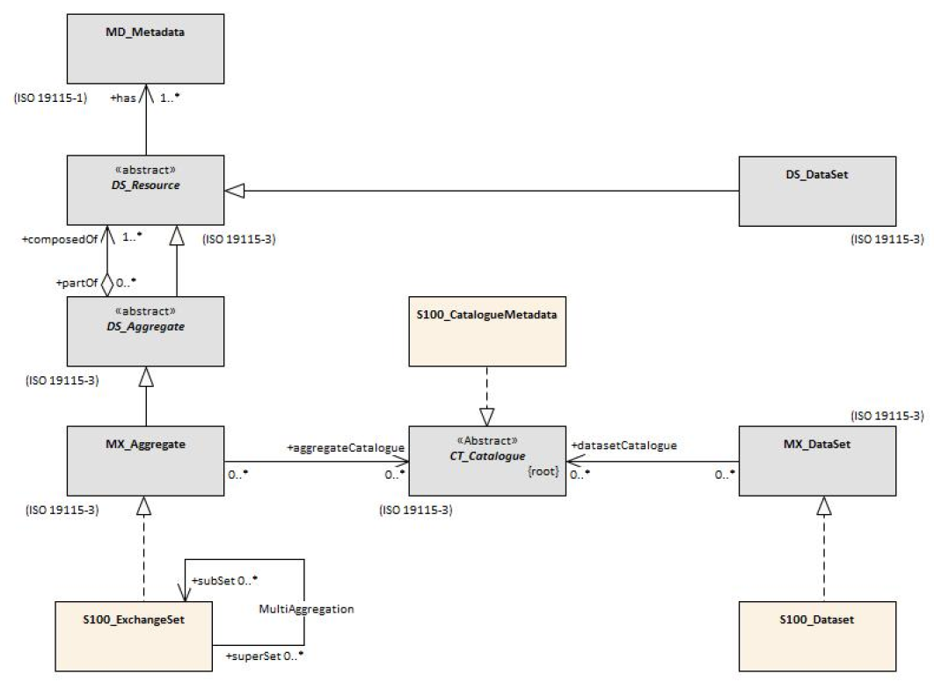
Figure 12.1 - Realization of the exchange set classes. Note that there are no support files

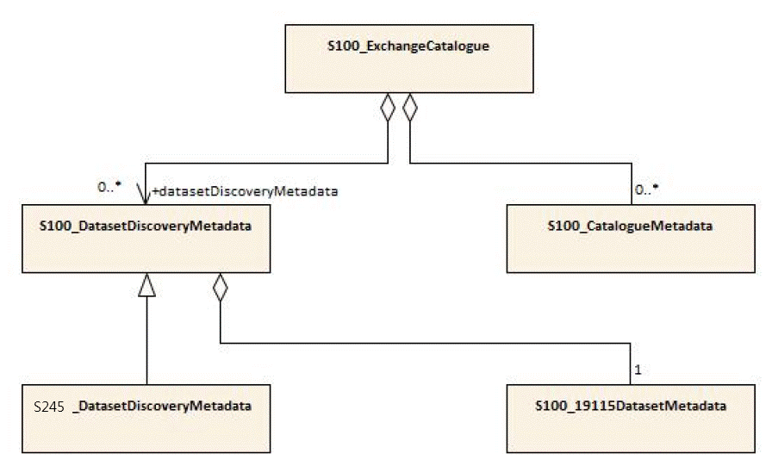
Figure 12.2 - S-245 ExchangeSet Catalogue

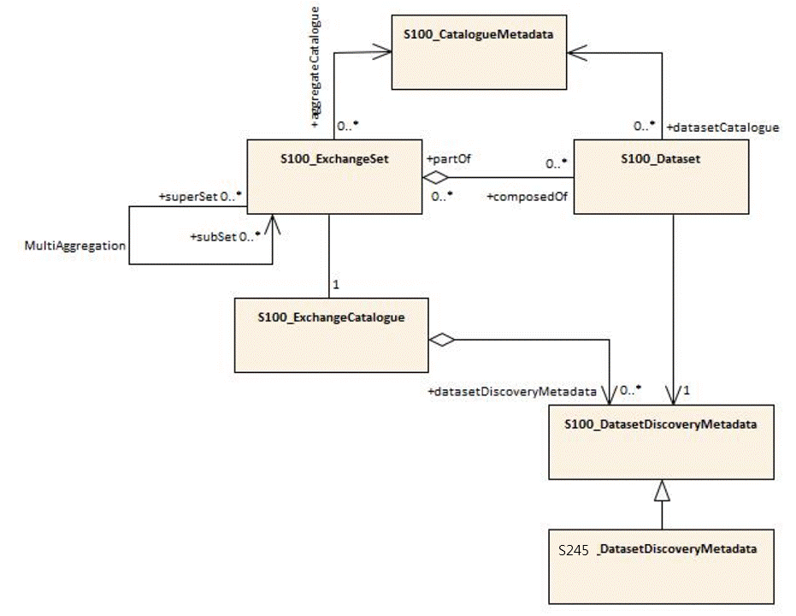
Figure 12.3 – S-245 ExchangeSet.
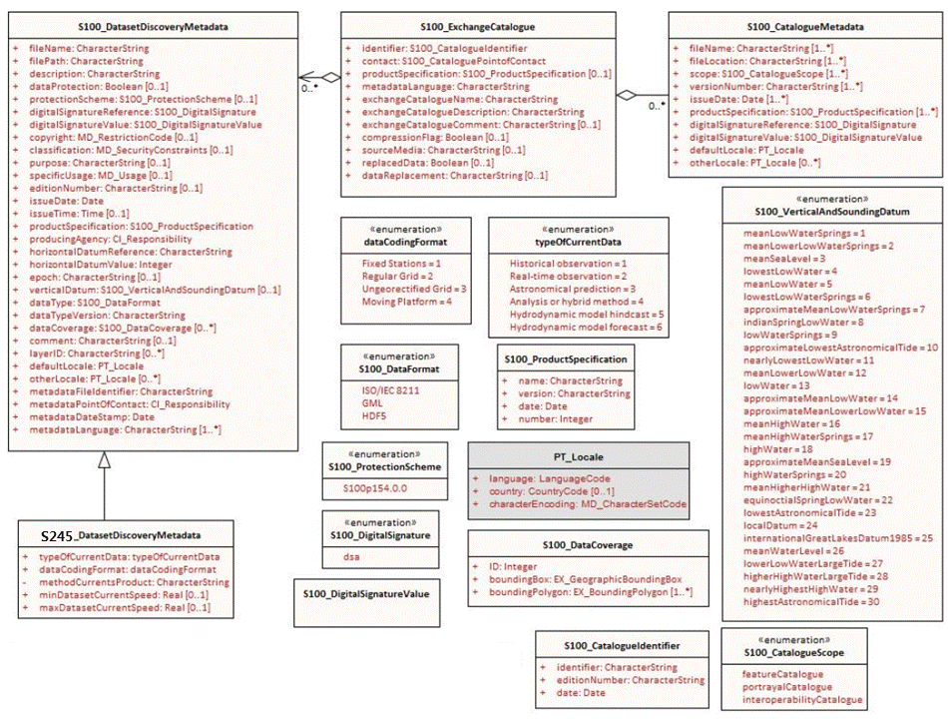
Figure 12.4 - S-245 Exchange Set: Class details.

